Market Timing Tactical Asset Allocation

INSEAD Masters in Finance (MFIN17M) – DRAFT Master Project

**Cameron Allan McLean**  
cameron.mclean@insead.edu

March 2017

ABSTRACT

In 2006-2013 Mebane Faber released papers outlining a quantitative approach to tactical asset allocation that proved to improve risk adjusted returns across various asset classes. In this paper I revisit Faber’s papers, replicate his model with updated data to the end of 2016 and apply the same quantitative method to a South African asset allocation to see if his observations hold true. I then analyse practical issues for both institutional and retail investors using this approach before combining topical ideas to the original research. [rewrite once finished]

Copyright Cameron Allan McLean

Contents

List of Figures and Tables 3

Introduction 4

Replication of A Quantitative Approach to Tactical Asset Allocation 4

Summary of the paper 4

Data used 4

Asset returns including data 2013-2016 5

Replication of Global Tactical Asset Allocation including 2013-2016 7

Analysis of performance 10

Diversification and Modern Portfolio Theory 10

Recent Performance and the Financialisation of Commodities 12

Performance under rising interest rates 17

Practical and behavioural implications for Trend Following Investors 19

Ideas and tests to improve Fabers results 32

A Quantitative Approach to Tactical Asset Allocation in South Africa 22

Data 22

Performance returns 1971-2016 23

Timing Signal 23

JALSH 24

MSCI WORLD 25

SA10YR 26

GSCI 27

JSAPY 28

Systematic Tactical Asset Allocation South Africa 29

Performance returns 2003-2016 including property 30

Improving returns 32

Comparison to local SA funds 34

Conclusion 36

Appendix 1 – Data validity check 37

Appendix 2 – Using R code 38

References 39

# List of Figures and Tables

[Create once finished]

# Introduction

[write once finished]

# Replication of A Quantitative Approach to Tactical Asset Allocation

## Summary of the paper

According to Peterson (2015), the first main step for research replication is to summarise the paper to make sure the paper and its research context is fully understood. My summary is as follows.

In July 2006, Mebane Faber began to circulate a working paper entitled A Quantitative Approach to Tactical Asset Allocation which was subsequently published by The Journal of Wealth Management in Spring 2007. In February 2009 Faber updated his paper to include data from 2006-2008 and then again updated the paper in February 2013 to include data from 2009-2012 as well as test the approach on alternative asset classes and allocations.

The purpose of Faber’s research was “to present a simple quantitative method that improves risk adjusted returns across various asset classes” (Faber 2013). Testing over 5 asset classes from 1973-2012, his approach improved risk adjusted returns in every asset class tested and when applied to an equal weighted asset allocation, resulted in equity like returns with bond like volatility and drawdowns.

The quantitative system used by Faber is based on one of the most well known trend following strategies commonly used by CTAs which uses a 200 day moving average to signal when to be long or move to safety. It met his criteria of being a simple, mechanical price based signal with non optimised parameters for all asset classes. Faber, testing with monthly data, adapted his approach to use the monthly equivalent 10 month simple moving average to signal when to get long or move to cash. The rules were simple; buy when the monthly price is greater than the 10 month simple moving average and sell and move to cash when the monthly price crossed below the 10 month simple moving average.

When applied to individual asset classes, the timing system consistently resulted in improved absolute returns, risk adjusted returns and max drawdowns. On average between 1973-2008 the timing system “increased returns by approximately 20%, decreased volatility by 20%, improved the Sharpe Ratio by 0.20 and reduced the maximum drawdown by nearly 50%” (Faber, 2009).

The results showed the simple moving average based market timing system could also be applied to global tactical asset allocation to significant improve the performance and risk metrics compared to a standard buy and hold strategy. The timing system had better absolute returns of 10.48% (vs 9.92% for the buy and hold), lower volatility of 6.99% (vs 10.28%) resulting in an improved Sharpe ratio of 0.73 (vs 0.43). Crucially for investors, the max drawdown of the timing model was only -9.54% (vs -46.00%) meaning that investors never experienced the pain of giving back more than 10% of their equity. Lastly in the 40 years of data between 1973-2012, the timing strategy remarkably only had 1 year of negative performance, which was a respectable -0.59%.

## Data used

Faber applied his quantitative approach to five asset classes – Domestic (US Large Cap) Equities, Foreign Developed Equities, US Bonds, Commodities and Real Estate. He chose publicly traded indices representing these asset classes and obtained monthly total return data series from Global Financial Data to use in his framework. The actual indices chosen were Standard and Poor’s 500 Index (S&P 500), Morgan Stanley Capital International Developed Markets Index (MSCI EAFE), United States Government 10yr Treasure Bonds (US10YR), Goldman Sachs Commodity Index (GSCI) and the National Association of Real Estate Investment Trusts Index (NAREIT).

Global Financial Data is a paid data provider unwilling to make their data available for academic purposes. Data used in this paper has been obtained from a variety of sources. S&P500, NAREIT, EAFE, GSCI total return index data are available on Bloomberg. To represent Fixed Income, 10yr US Government Bond Yields were obtained from FRED and a total return index that takes into consideration both capital appreciation and income has been created following the methodology of Morningstar. A similar index was created using 3 month US Treasury Bond Yields to represent risk free returns. Overall differences in performance results are minimal and outlined in appendix [X]. Although there are small discrepancies I am confident the datasets are close enough to the original data that the results in the paper are valid.

## Asset returns including data 2013-2016

Faber first charts the asset class returns to see the routes they travelled from start to finish. The replication of this chart below and comparing it to Faber’s Figure 3 (page 16) between 1973-2012 visually confirms the data obtained closely matches the data Faber original used provided by Global Financial Data. Extending this chart to the end of 2016, we can see what has happened over the last 4 years of returns.

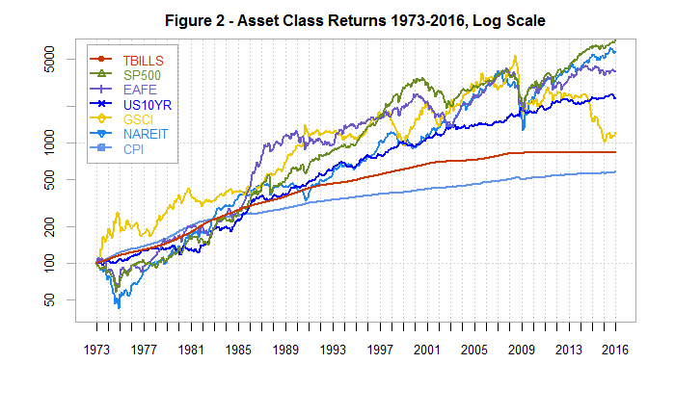

It is clear to see most assets have continued to deliver positive returns however commodities (GSCI) has continued to underperform since it’s all time high in 2008. Zoomed in and rebasing at 2012 to confirm its much more obvious.

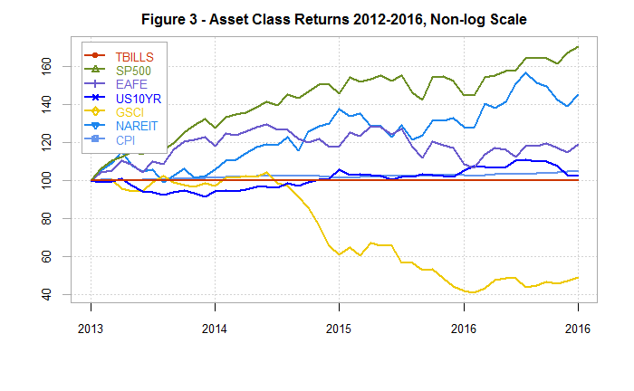

Replicating performance statistics over the same set of asset classes we get very similar results to Faber’s research confirming the visual check above that the data is accurate.

|  |  |  |  |  |  |  |
| --- | --- | --- | --- | --- | --- | --- |
| **Figure 4 - Asset Class Maximum Drawdowns 1973-2012** | | | | | | |
|  | TBILLS | SP500 | EAFE | US10YR | GSCI | NAREIT |
| Return | 5.42% | 9.77% | 9.19% | 8.12% | 8.34% | 9.64% |
| Volatility | 0.95% | 15.71% | 17.60% | 8.47% | 20.55% | 18.16% |
| Sharpe (??%) | 0.00 | 0.26 | 0.20 | 0.30 | 0.13 | 0.22 |
| MaxDD | 0.00% | -50.95% | -56.40% | -15.75% | -67.65% | -68.18% |
| Inflation CAGR | 4.33% | 4.33% | 4.33% | 4.33% | 4.33% | 4.33% |

Extending this to include 2013-2016:

|  |  |  |  |  |  |  |
| --- | --- | --- | --- | --- | --- | --- |
| **Figure 6 - Asset Class Maximum Drawdowns 1973-2016** | | | | | | |
|  | TBILLS | SP500 | EAFE | US10YR | GSCI | NAREIT |
| Return | 4.93% | 10.18% | 8.75% | 7.41% | 5.85% | 9.65% |
| Volatility | 1.00% | 15.30% | 17.21% | 8.33% | 20.52% | 17.81% |
| Sharpe (5.41%) | 0.00 | 0.33 | 0.21 | 0.28 | 0.04 | 0.25 |
| MaxDD | 0.00% | -50.95% | -56.40% | -15.75% | -80.90% | -68.18% |
| Inflation CAGR | 4.04% | 4.04% | 4.04% | 4.04% | 4.04% | 4.04% |

Looking at the effect of the last four years on Faber’s research:

|  |  |  |  |  |  |  |
| --- | --- | --- | --- | --- | --- | --- |
| **Figure 7 - Changes to Asset Class Maximum Drawdowns 1973-2016** | | | | | | |
|  | TBILLS | SP500 | EAFE | US10YR | GSCI | NAREIT |
| Return | -0.49% | 0.41% | -0.44% | -0.71% | -2.49% | 0.01% |
| Volatility | 0.05% | -0.41% | -0.39% | -0.14% | -0.03% | -0.35% |
| Sharpe (5.41%) | 0.00 | 0.06 | 0.01 | -0.02 | -0.09 | 0.03 |
| MaxDD | 0.00% | 0.00% | 0.00% | 0.00% | -13.25% | 0.00% |
| Inflation CAGR | -0.29% | -0.29% | -0.29% | -0.29% | -0.29% | -0.29% |
|  |  |  |  |  |  |  |
|  | | | | | | |
|  | TBILLS | SP500 | EAFE | US10YR | GSCI | NAREIT |
| Return | -8.87% | 4.95% | -4.58% | -9.41% | -29.69% | 0.00% |
| Volatility | 5.26% | -2.49% | -2.27% | -1.30% | -0.15% | -1.77% |
| Sharpe (5.41%) | 0.00 | 0.21 | 0.01 | -0.14 | -0.70 | 0.10 |
| MaxDD | 0.00% | 0.00% | 0.00% | -0.25% | 19.59% | 0.44% |
| Inflation CAGR | -6.05% | -6.05% | -6.05% | -6.05% | -6.05% | -6.05% |

A few noticeable changes stand out:

* Adding 4 more years of data to nearly 40 years of existing data, has reduced the CAGR for commodities CAGR from 8.34% to 5.85%, roughly a 30% reduction drop. The stats also confirm what we see visually with commodities max drawdown increasing to 80%.
* TBILL CAGR have dropped – which makes sense considering near zero rates recently.

## Replication of Global Tactical Asset Allocation including 2013-2016

Looking at the percent of time invested including the most recent years:

|  |  |  |  |
| --- | --- | --- | --- |
| **Figure 11 - Percent of the Time Invested, 1973-2016** | | | |
| Number of Positions | % Invested | # of Months | % of Months |
| 0 (all cash) | 0% | 6 | 1.13% |
| 1 | 20% | 32 | 6.05% |
| 2 | 40% | 62 | 11.72% |
| 3 | 60% | 118 | 22.31% |
| 4 | 80% | 192 | 36.29% |
| 5 | 100% | 119 | 22.50% |
| TOTAL |  | 529 | 100.00% |

The strategy is invested approx. [71% - get exact] of time which is in line with expectations from previous periods.

Looking at the GTAA model extended to include the most recent years

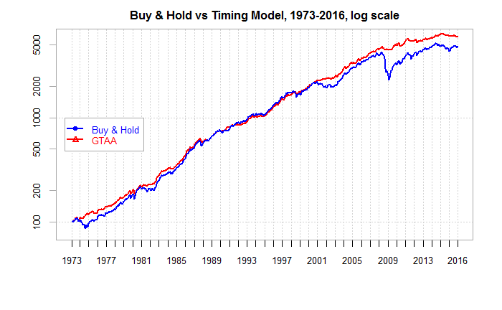

Looking at non log chart for the extended data.

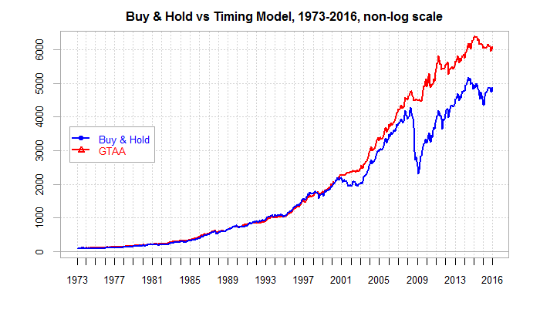

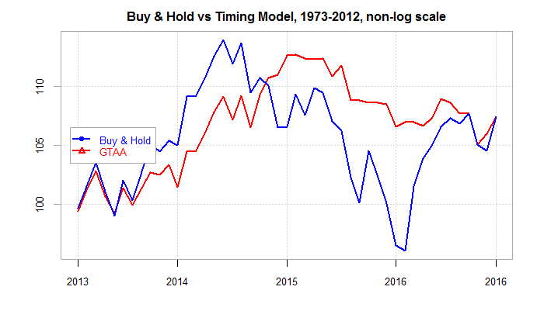

Buy and hold outperformed earlier, then GTAA outperformed with less downside before BH caught up. Look at drawdowns and standard deviation to highlight this point.

|  |  |  |
| --- | --- | --- |
| **Summary Annualised Returns for B&H vs Timing Model, 1973-2012** | | |
|  | Buy & Hold | GTAA |
| Return | 9.93% | 10.57% |
| Volatility | 10.28% | 7.01% |
| Sharpe | 0.41 | 0.68 |
| MaxDD | -46.10% | -9.56% |
| Inflation CAGR | 4.33% | 4.33% |

|  |  |  |
| --- | --- | --- |
| **Summary Annualised Returns for B&H vs Timing Model, 1973-2016** | | |
|  | Buy & Hold | GTAA |
| Return | 9.25% | 9.80% |
| Volatility | 10.09% | 6.87% |
| Sharpe | 0.35 | 0.59 |
| MaxDD | -46.10% | -9.56% |
| Inflation CAGR | 4.04% | 4.04% |

|  |  |  |
| --- | --- | --- |
| **Summary Annualised Returns for B&H vs Timing Model, 2013-2016** | | |
|  | Buy & Hold | GTAA |
| Return | 2.67% | 2.44% |
| Volatility | 7.78% | 4.92% |
| Sharpe | -0.35 | -0.60 |
| MaxDD | -15.62% | -6.74% |
| Inflation CAGR | 1.25% | 1.25% |

|  |  |  |
| --- | --- | --- |
| **Summary Annualised Returns for B&H vs Timing Model, 2007-2016** | | |
|  | Buy & Hold | GTAA |
| Return | 2.67% | 3.89% |
| Volatility | 13.23% | 6.55% |
| Sharpe | -0.21 | -0.24 |
| MaxDD | -46.10% | -9.22% |
| Inflation CAGR | 1.81% | 1.81% |

[confirm Shape calcs negative]

The last 4 and 10 years haven’t been great for absolute returns. Compared to the 30 year period before where both strategies were returning approx. 10%, CAGR for both buy and hold and timing model have been 2-4% far below expectations based on previous periods. This during a time when major benchmarks [show rolling performance vs S&P] such as the S&P and Dow Jones are making regular news headlines for new all time highs. Although long term results have been very respectable with an overall CAGR of approx. 10% and a max drawdown of -10%, it’s easy to imagine investors questioning their choice of strategy right now.

# Analysis of performance

## Diversification and Modern Portfolio Theory

One of the core drivers of the absolute returns of the strategies within Faber’s paper is diversification. “Diversification is often spoken of as the only free lunch in investing” (Jennings and Payne, 2016) and has the ability to enhance returns without necessarily increasing risk. The proverb “don’t put all your eggs in one basket” explains it succinctly; invest in a portfolio of different assets and you’ll always have less (or at most equal) risk to the riskiest asset on its own. The benefits of diversification are no secret and have been acknowledged for thousands of years. Even the bible, thought to have been written by Solomon around 900BC, tells the reader to “divide your investments among many places, for you do not know what risks might lie ahead” (Ecclesiastes 11:2). Today some successful hedge fund managers see diversification as “the single most important factor to influence the overall long term results” (Clenow 2013, p. 52).

In 1952 Dr Harry Markowitz published his seminal paper Portfolio Selection (Markowitz 1952) introducing practitioners to a mathematical framework that explained the well-known benefits of portfolio diversification. Stating rational investors desired returns and disliked variance, he hypothesised the E-V rule used to create efficient portfolios of diversified securities. Although admitting that diversification could not completely eliminate all variance, by using the E-V rule an investor is able to derive an optimal portfolio of assets with either the lowest risk for a given level of expected return or the highest expected return for a given level of risk. Markowitz’s paper notes that although the E-V rule identifies diversification as a driver for more efficient portfolios, it requires the right kind of diversification with a selection of securities with low covariance among themselves. Markowitz’s work contributed to what is known today as Modern Portfolio Theory and eventually won him a Nobel prize in 1990.

Modern Portfolio Theory has several criticisms however. The risk, return and correlation inputs into the model are based on expected values assumed to stay constant over time and returns are assumed to follow a Gaussian/normal distribution. Risk in modern portfolio theory is represented by variance, however its questionable whether rational investors will still dislike variance when an asset is moving in the desired direction. Modern portfolio theory manages risk through diversification however it ignores that during extreme market panic, correlations tend towards one. [insert chart of correlations between 5 asset classes]. Global financial market crises in the late 1980s, early 2000s and 2007-2009 have shown that in these times diversification does little to reduce downside risk. Here is where trend following strategies can add value to a diversified portfolio.

Trend following is a simple concept – identify a trend and follow it. When things move against you or when the trend is no longer there, take your profits or cut your losses. The strategy has had plenty of criticism over the years especially from classical economists preaching efficient markets. However strong performance numbers, especially during periods of extreme equity markets drawdowns, has seen the use of trend following rapidly grow as an investment strategy over the last 40 years.

Greyserman and Kaminski (2014) analyse the performance of trend following from 1223 to 2013 using a simple trend following strategy over a unique dataset for 84 markets in equity, fixed income, foreign exchange and commodity markets. They find trends exist in market prices due to fundamental, technical and behaviour reasons but ultimately conclude that trend followers don’t care about the underlying reason and just want to ride the trend whenever the opportunity arrives. They find the driver of performance in a trend following strategy to be the ability to cut losses and take profits rather than the entry signal to get into the trend. Covel (2009) identifies that trend following traders use mechanical trading systems to gain this ability to cut losses and take profits. Mechanical trading systems are based on an objective set of rules and remove discretionary decisions subject to emotion and behavioural biases.

Ultimately trend following strategies are risk reduction techniques. They remove exposure to a position during long periods of drawdown without necessarily penalising overall long term returns. A simple mechanical trend following strategy helps to avoid behavioural biases humans exhibit when making trading decisions such as [loss aversion – detail more in behavioural]. By managing the downside, returns that are usually negative skewed with excess kurtsis are changed in positive skewed. [insert charts comparing buy and hold vs timing returns to show mean/skew/kurtosis]. Faber (2007) identifies that most common asset classes experience painful drawdowns with multiple examples of 40-100% drawdowns. Trend following reduces volatility and by being out of markets during substantial periods of decline avoids long painful drawdowns for the investor.

Faber’s simple five asset class equal weighted asset allocation, even on a buy and hold basis, presents evidence of the benefits of diversification. The trend following timing overlay manages risk and results in reduction of volatility from 20% to 10%. Crucially the timing signal reduces portfolio drawdowns to the point that the investor only experience one down year since 1973, with that being -1%. Trend following isn’t about achieving superior absolute returns – it’s about avoiding the painful drawdowns which can destroy many previous years of gains. This combined with the power of compounding may result in equal or even better absolute returns, however more importantly consistently provides improved risk adjusted returns.

## Recent Performance and the Financialisation of Commodities

It’s apparent since Faber originally published his first working paper in 2006, performance numbers of the equal weighted 5 asset class buy and hold portfolio haven’t been as impressive. With the global financial crash in 2008, CAGR between 2006-2016 dropped to 2.54% compared to the 11.27% seen between 1973-2006. Volatility also increased from 8.92% to 13.18% and perhaps most painfully felt by investors, the model had its biggest drawdown ever experiencing a drawdown of 46.1% which was more than double compared to the previous periods max drawdown of 19.61%. The Sharpe ratio from 1973-2006 of 0.53 dropped to 0.14 in the following 10 years. [Confirm these calcs – especially sharpe]. Was Faber’s model overfitted or can this performance of the last 10 years be explained elsewhere?

Reviewing the individual returns of each asset class, it’s clear that commodities were the worst performing asset class and dragged the overall performance of the diversified portfolio down. Since 2006, commodities have a CARG of -8.71%, volatility higher than all other asset classes of 23.6%, as well as a max drawdown of 80.9% in a period where equity and bond returns have continued to show a positive CAGR despite also suffering drawdowns in 2008 where they lost over half their value.

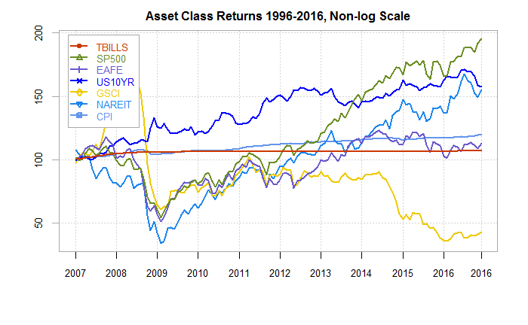

With hindsight if commodities were excluded from the portfolio, the returns would have been considerably better [insert returns for 2006-2016 period with only 4 asset classes vs 5 assets. Then insert summary of period 1973-2006 to see difference].

It’s not the first financial crash in this period yet performance numbers were much more effected by the performance of commodities. Why? It appears commodity correlations have increased like never seen before. [show correlation charts of commodities vs each major market event since 1973]

A popular topic around the time of Faber’s first white paper was the strong diversifying performance of commodities. Two years before Faber first released his first working version, Gorton and Rouwenhorst released a working paper of Facts and Fantasies About Commodity Futures (2004) highlighting commodities as an ideal diversifier for equity and bond portfolios. They showed that an equal weighted index of commodity futures between 1959 and 2004 produced equity-like returns, slightly lower risk than stocks as measured by standard deviation and less downside risk due to positively skewed returns with relatively high kurtosis. With a negative correlation with both stocks and bonds over most horizons, they concluded commodities as being an especially effective in providing diversification over both stock and bond portfolios.

Following this, in 2006 Ibbotson Associates released a report for PIMCO titled Strategic Asset Allocation and Commodities [2006] that analysed the role of commodities within a strategic asset allocation setting. Comparing the returns from 1970 to 2005 of a composite commodity index against US and International stocks, US and International Bonds, Treasury Bills and Inflation, they found that commodities were the top performing asset. During periods of high inflation commodities had the highest arithmetic and compounded returns by a wide margin and in periods of low margin they still returned double digit returns. Ibbotson Associates also identified that commodities had the lowest average correlation to the other asset classes, concluding that including commodities in an asset allocation improved the risk return characteristics of the efficient frontier.

These papers combined with other literature (Erb and Harvey, 2004) drove increased long only investment into commodities financial instruments by managers looking to improve risk adjusted portfolio performance. Hundreds of billions of dollars (Irwin and Sanders, 2011 and Bhardwaj, Gorton and Rouwenhorst, 2014) of inflows into commodity investments created structural changes later termed financialisation by Domanski and Heath (2007)

As a result of financialisation, it was thought commodities were no longer driven purely by commodity fundamentals and rather by macroeconomic views of investment managers, increasing correlations among commodities and other asset classes. Zaremba (2015) provides one of the more intuitive explanations for this increase in correlation. With an increased number of financial investors holding on to a similar asset allocation of stocks, bonds and commodities, any external shock causing severe capital outflows will enforce selling of all asset classes in the portfolio at the same time to free up capital, causing correlation to rise. A resulting theme in recent research [Silvennoinen and Thorp 2009, Cheung and Miu 2010, Bhardwaj, Gorton, and Rouwenhorst 2014] reviews financialisation and the recent performance of the commodities sector since financialisation and raised the idea that commodities should no longer be included in a diversified investment portfolio. They conclude that commodities may no longer provide diversifying protection in future times of financial distress similar to the global financial crisis of 2008.

Today there are arguments for both including and excluding commodities in an asset allocation. On one hand commodity correlations have returned towards pre 2008 financial crisis levels and there is a wealth of research [Bhardwaj, Gorton, Rouwenhorst 2015, Levine, Ooi and Richardson 2016] reporting commodities to have strong returns during periods of growth and high inflation as well as low correlation with stocks and bonds over long horizons, concluding that despite the most recent years performance commodity futures are still likely to add diversification protection to a portfolio of assets under these regimes.

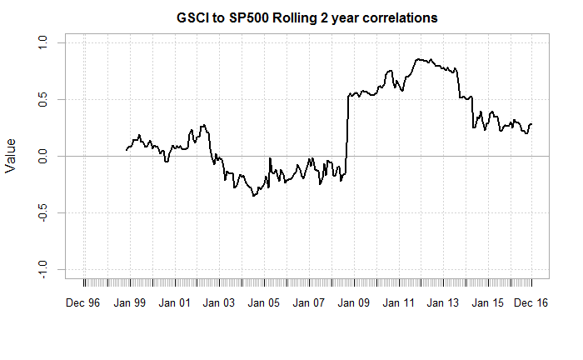

On the other hand, many (Zaremba 2015, Lombardi and Ravazzolo 2013) have argued that the diversification benefits of commodity may not be valid anymore. Due to the structural changes from the financialisation of commodities, increased correlations especially during macro market shocks, it has been argued that commodities no longer offer diversification protection for a portfolio with stocks and bonds during a financial crisis. Antonacci (2017) also argues that due to the nature of commodity markets changing from financialisation, the papers using data before this period succumb to aggregation bias and will have less forecasting power for the period following financialisation.

Without being able to predict the future and prove which argument is correct, it’s perhaps now a good time to review the performance of the timing model between 2006-2016. Like the buy and hold portfolio, returns were less (3.9% vs 11.6%) however volatility reduced resulting in a far less decrease of the Sharpe ratio than expectations. Most importantly for investors, the max drawdown stayed in line with expectations and was only -9.2% during the financial crisis. Its apparent that the trend following timing model mitigates some of the negative impact of financialisation during crises, removing the investor from commodities during sharp drawdowns. Potentially entering a period where expectations are that inflation and growth will increase, supports including commodities in the diversified portfolio. The timing strategy allows the investor to gain any potential upside under these regimes, whilst protecting the investor somewhat in a financial crisis, where it’s not unreasonable to expect correlations to again increase towards one for all asset classes.

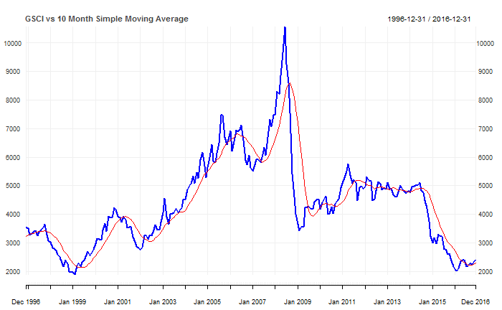

2006-2016

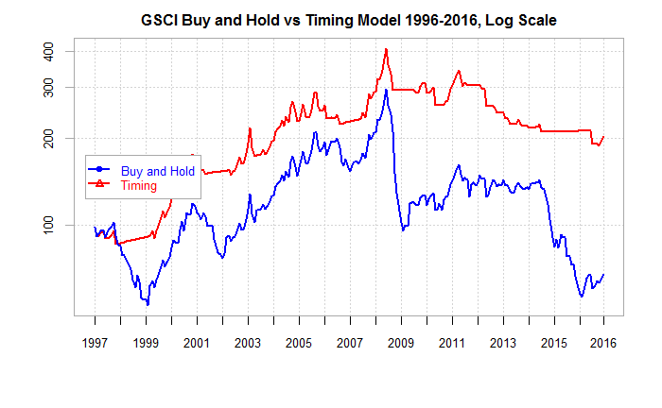

GSCI Buy and Hold TIMING

Return -1.86 3.64

Volatility 22.84 15.87

Sharpe -0.23 0.00

MaxDD -80.90 -53.93

% Positive Months 0.00 0.00

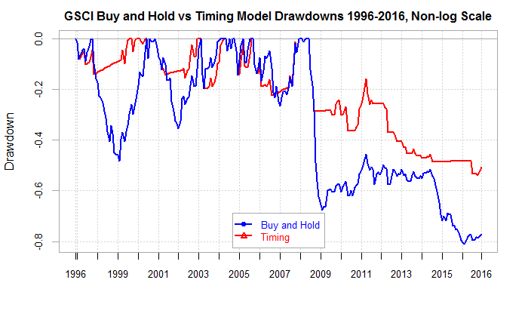

## Performance under rising interest rates

It’s no secret that we have just experienced one of the longest bull markets for fixed income. US Government 10 year Bond yields have steadily fallen from all times highs of approx. 16% in 1981 to approx. 2% today. This has resulted in a 30+ year bull market for bond returns.

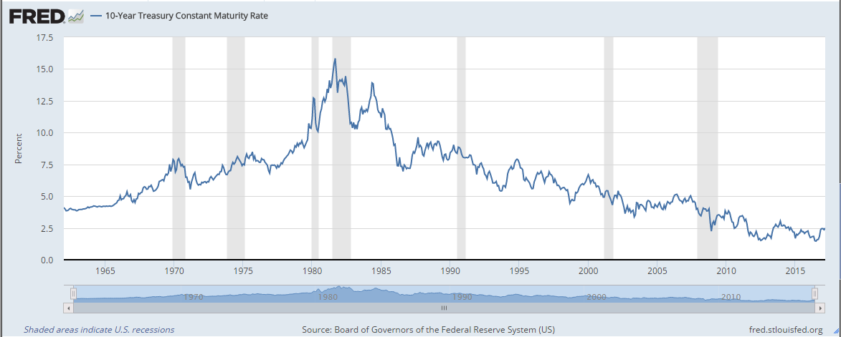

[enter own chart with yield and US10YR returns]

Inflammatory headlines are common, especially regarding CTA or trend following performance in a rising rates cycle. Due to its relative popularity, some investors are concerned that trend following strategies only generate positive risk adjusted returns during periods of falling rates.

To analysis potential performance under a rising rates regime, let’s review the period 1973-1981 where it was a clear rising rates environment.

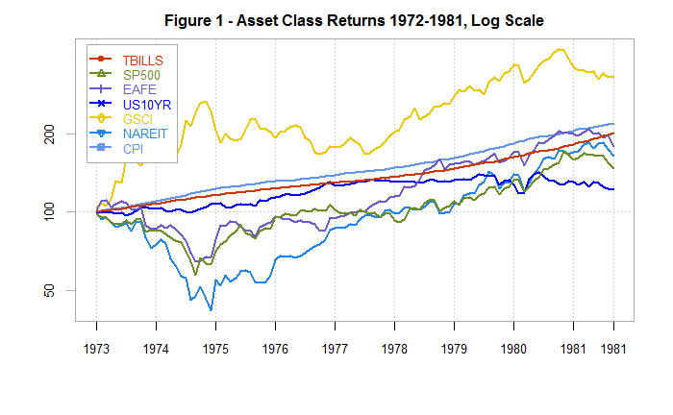

|  |  |  |  |  |  |  |
| --- | --- | --- | --- | --- | --- | --- |
|  | TBILLS | SP500 | EAFE | US10YR | GSCI | NAREIT |
| Return | 8.27% | 4.54% | 6.82% | 2.24% | 14.50% | 5.87% |
| Volatility | 0.87% | 16.64% | 16.83% | 8.42% | 23.67% | 22.32% |
| Sharpe (8.27%) | 0.00 | -0.21 | -0.08 | -0.67 | 0.24 | -0.10 |
| MaxDD | 0.00% | -42.65% | -41.53% | -15.75% | -37.45% | -58.10% |
| Inflation CAGR | 9.38% | 9.38% | 9.38% | 9.38% | 9.38% | 9.38% |

Looking at the GTAA, the portfolio was invested approximately 71% of the time.

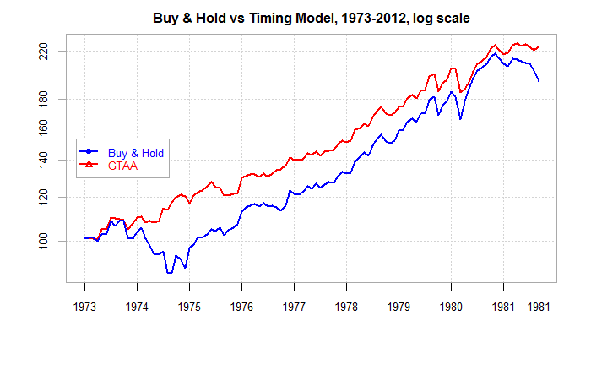

|  |  |  |
| --- | --- | --- |
|  | Buy & Hold | GTAA |
| Return | 8.09% | 9.86% |
| Volatility | 10.71% | 8.19% |
| Sharpe | -1.35 | -1.55 |
| MaxDD | -19.61% | -9.56% |
| Inflation CAGR | 9.31% | 9.31% |

[Check Sharpe ratio!]

It’s clear that even under an environment of rising rates the trend following strategy adds value. [Why? Go into detail about avoiding drawdowns? Diversification of commodities?]

# Practical and behavioural implications for Trend Following Investors

* Retail costs, behavioural finance aspects of sitting in strategy underperforming, too simple?
* Institutional investor benchmarks
* Clenow (2013) comments that although trend following strategies are easy, “sticking with them in reality is a whole different ball game”.
* Criticism of trend following – look in clenow - Long drawdowns, underperformance in bull markets
* Trend following strategies are dominated by a large percentage of small losing trades with a few large winners. Show distribution, can investor handle being wrong most of the time?
* the ability to cut losses and let winners run is opposite of investors natural instincts. (hence mechanical)
* Negative skew (koulajian and cskwianianc 2011). Are all asset classes negatively skewed? If so (equities go up the stairs, down the lift) then trend following helps cut the losses
* Although the diversification in the asset allocation reduces volatility risk, investors exhibit behavioural biases which work against the strategy.
* Tracking error aversion: investors are likely to track their investment to popular benchmarks like the S&P 500. Any underperformance relative to this benchmark, or even the buy and hold version of the asset allocation, will create doubt for the investor that they have selected the right strategy. Of course with hindsight it will be easy to identify the perfect asset allocation, removing asset classes that have underperformed and replacing them with allocations to the best perofmraning asset allocations. However would investors have been able to stick with this strategy. [Talk about study by newfound about god being a manager and how he would be fired]. Faber identifies his strategy underperforming in bull markets such as the equities market in 1990s. During these times will investors be able to stick to the strategy despite it underperforming each year. [look at rolling returns]. Humans are fickle, every bull market is apparently different and we have learned from the past. Humans greed / fear of missing out compared to the neighbours
* Doing nothing: with a timing model investors need to be able to follow the rules – might not be able to sit on their hands. *There is the plain fool, who does the wrong thing at all times everywhere, but there is also the Wall Street fool, who thinks he must trade all the time. Lefevre (reminiscences of a stock operator)*
* *The market does not beat them. They beat themselves, because though they have brains they cannot sit tight. Old Turkey was dead right in doing and saying what he did. He had not only the courage of his convictions but also the intelligence and patience to sit tight.*
* In times of underperformance?
* Tracking error – create worst 10 years with corresponding B&H and JALSH returns as well as rolling returns chart to show periods of underperformance. Would investor be able to stick when other side of the fence looks better. Would hedge fund manager be able to keep clients or would they be fired
* Daily drawdowns – makes strategy feel worse
* People like to trade [market timing JSE article
* Faber (ivy 2009) highlights that a trend following model will underperform a buy and hold strategy during a strong bull market. He also highlights the timing requires discipline (value of rules based approach) and you can have multiple losing trades in a row. (Humans don’t like being wrong bias).
* Active vs Passive - Evidence should an active model can consistently beat passive. However biggest thing is fees – if someone is going to charge 2% and 20% to do this then not worth it (show with stats?). The resulting average returns (13% vs 4.8% for buy and hold) with similar standard deviation (11.2% vs 10.3# for buy and hold) gives the trend following strategy a far superior sharpe ratio (1.16 vs 0.47 for the buy and hold) highlighting the value in actively trading vs passively buying and holding.
* Markets are known to rise on the elevator fall by the lift. In times of panic, the majority of investors are net long? Panic creates fear of losing. Faster emotional than greed?
* “Ilmanen (2011) and Friesen et all (2009) offer explanations as to why trend following may have been successful historically, including the tendency for investors to underreact to news and their tendency to exhibit herding behaviour” - trend is our friend clare et all
* Leverage and portfolio theory - Portfolio theory is you find the optimal portfolio and leverage up. Problem with leverage is it can be fatal for levered investors. Based on volatility. Past volatility. But what does volatility actually mean for an investor. Take 2008 (inker 2010) a levered investor would have been forced to sell…

# A Quantitative Approach to Tactical Asset Allocation in South Africa

South Africa has a very traditional investment industry that has lagged the world adopting recent investment trends such as indexation (Morningstar 2015). It is estimated that X% of funds invested are actively managed and of these funds a large majority are discretionary managed rather than quantitative. How will a quantitative strategy like Faber’s perform when applied to local assets and compare to the top ranking managers.

## Data

The biggest challenge to apply the strategy to South Africa is obtaining a long enough period of historical price data for each asset class in South Africa. Ibbotson et al (2016) view long periods of data as vital for uncovering “the basic the relationships between risk and return among the different asset classes”. With a long enough period, the data will capture major market events as well as periods under different regimes such as growth and decline or inflation and deflation. Although history is unlikely to repeat, infamous market crashes and financial crises in different asset classes around the world are common throughout history all the way back to the 1600s with the infamous tulip bubble crash. In one way or another, despite the common view that markets walk a random path, it shows that history tends to repeat itself and a long period of data may hold some level of predictive value in the future.

Unfortunately for South Africa, historical performance data for each asset class is difficult to find for long periods of history and near impossible for asset classes such as property. Domestic equity market data is available from the local Johannesburg Stock Exchange going back to 1960 however even they cannot guarantee that the data is completely accurate as some of it was captured prior to the current FTSE/JSE joint venture in 2002. Previous local research (Firer and McLeod, 1999) found that before 1960 data was never systematically collected and published. It was found during this study, that previous work collecting data (including Firer and McLeod) had been lost once the researcher had changed career paths or unfortunately passed away. Copies of data handed down researcher to researcher exist, however the validity of some of this data is questionable especially after finding inconsistencies when reviewing and comparing time periods where multiple data sets overlap.

To create long data sets of historical returns for South African asset classes, I have used the best quality most recent data spliced to the most reliable of the available older data. This is summarised by the following table.

|  |  |
| --- | --- |
|  | Source |
| Domestic Equities | 2002-2016: FTSE/JSE All Share Total Return Index |
| 1970-2002: JSE/Actuaries All Share Index with dividends allocated evenly over the year |
| Foreign Equities | 1971-2016: MSCI World Total Return Index in ZAR |
| Fixed Income | 2002-2016: JSE ALBI Total return index |
| 1971-2002: Total return index created using 10 yr Government Bond Yields for South Africa provided by IMF on FRED |
| Commodities | 1971-2016: S&P GSCI Total Return Index in ZAR |
| Property | 2002-2016: FTSE/JSE SA Listed Property Total Return Index |
| 1992-2002: Property sector total return data provided by local asset manager |
| Inflation | 1971-2016: South Africa CPI Index (Statistics South Africa) |
| Risk Free | 1971-2016: Risk free / Cash index created using Treasury Bill Yields for South Africa provided by IMF on FRED |

## Performance returns 1971-2016

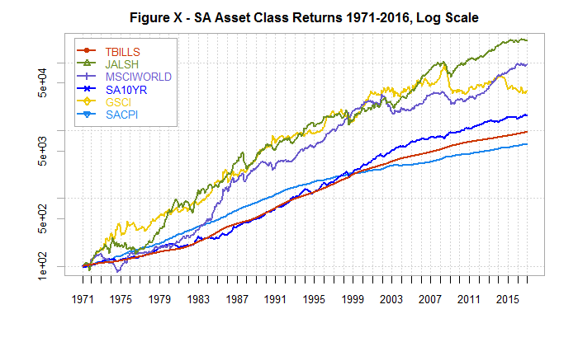

|  |  |  |  |  |  |
| --- | --- | --- | --- | --- | --- |
|  | TBILLS | JALSH | MSCIWORLD | SA10YR | GSCI |
| Return | 10.53% | 18.48% | 15.87% | 12.00% | 13.60% |
| Volatility | 1.26% | 20.99% | 17.42% | 7.35% | 22.88% |
| Sharpe (10.43%) | 0.00 | 0.34 | 0.28 | 0.18 | 0.12 |
| MaxDD | 0.00% | -42.45% | -49.90% | -18.63% | -64.08% |
| Inflation CAGR | 9.48% | 9.48% | 9.48% | 9.48% | 9.48% |

Over the period:

* Domestic equities have the best absolute returns of 18.48% followed by foreign equities with 15.87%
* Commodities still return 13.60% - shows the effect of the ZAR weakening boosting returns in local ZAR.
* Much higher inflation and risk free rate than the original US allocation

## Timing Signal

Let’s look at the asset returns individually and how the timing signal affect returns. Its interesting to note with South Africa assets that the timing model consistently resulted in better risk adjusted returns, usually by a reduction in volatility than better absolute returns. JALSH was an exception – it had a worse MaxDD and equal sharpe. [rewrite and mention this is where using multiple period moving averages would solve]

### JALSH

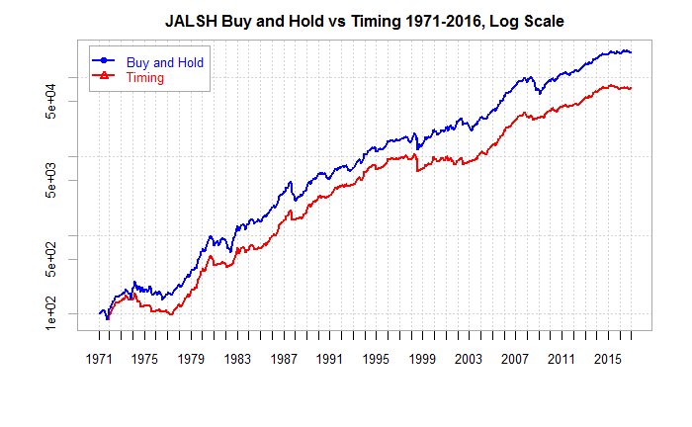 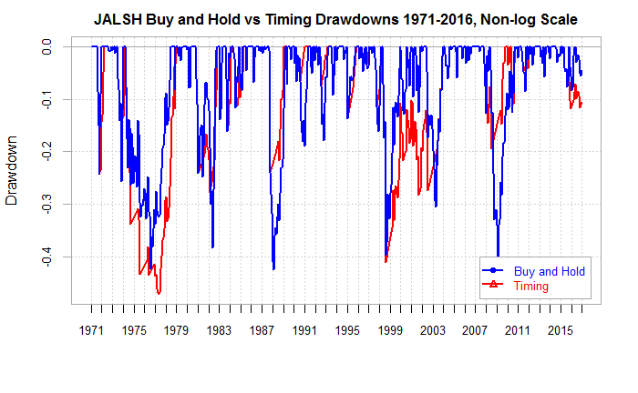

|  |  |  |
| --- | --- | --- |
|  | Buy and Hold | Timing |
| Return | 18.48% | 16.15% |
| Volatility | 20.99% | 17.28% |
| Sharpe | 0.68 | 0.68 |
| MaxDD | -42.45% | -47.02% |
| % Positive Months |  |  |

[Need to add $100 becomes… Sharpe RF, fix scale]

Commentary:

* Interesting drawdown is the same – unusual for this strategy but have checked its real
* Timing model doesn’t add much value in this case
* There is always exceptions to any rule and it appears JALSH bucks the trend with the timing model not return significantly better risk adjusted returns. Analysing why – 1988
* Demonstrates power of compounding after an early loss

### MSCI WORLD

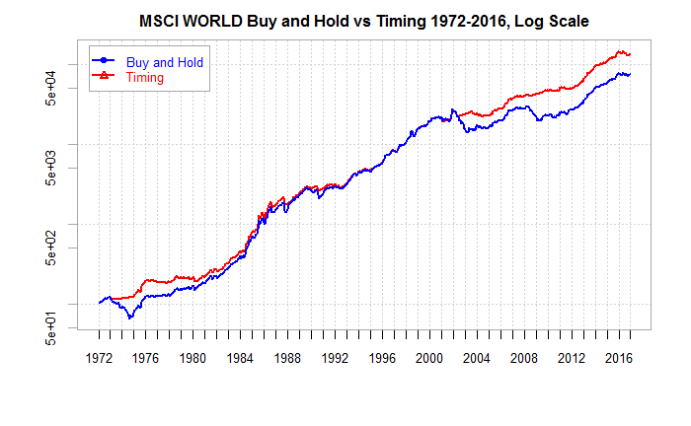

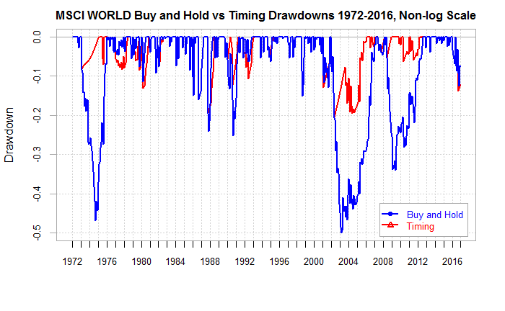

|  |  |  |
| --- | --- | --- |
|  | Buy and Hold | Timing |
| Return | 15.87% | 17.35% |
| Volatility | 17.42% | 15.09% |
| Sharpe | 0.69 | 0.90 |
| MaxDD | -49.90% | -20.54% |
| % Positive Months |  |  |

[Need to add $100 becomes… Sharpe RF, differences column, position chart]

Commentary:

* Much better results for the timing model in all performance measures

### SA10YR

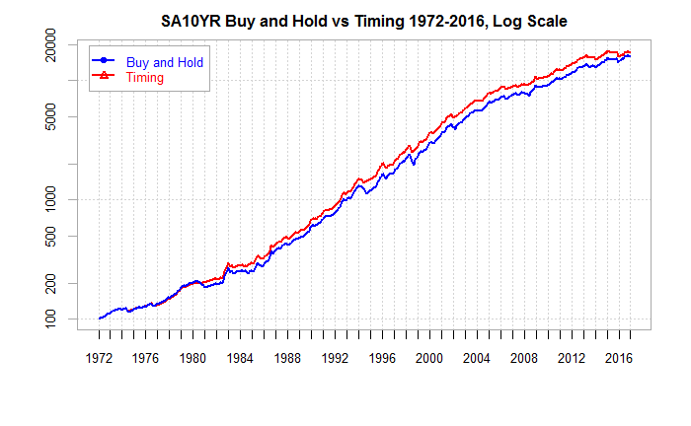

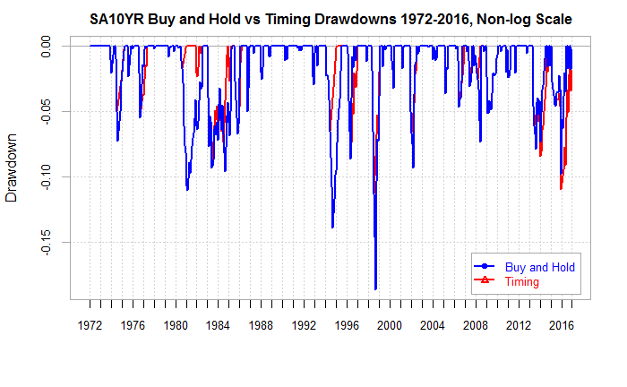

|  |  |  |
| --- | --- | --- |
|  | Buy and Hold | Timing |
| Return | 12.00% | 12.19% |
| Volatility | 7.35% | 6.62% |
| Sharpe | 1.05 | 1.21 |
| MaxDD | -18.63% | -11.35% |
| % Positive Months |  |  |

[Need to add $100 becomes… Sharpe RF, differences column]

Commentary:

* Much better results for the timing model in all performance measures

### GSCI

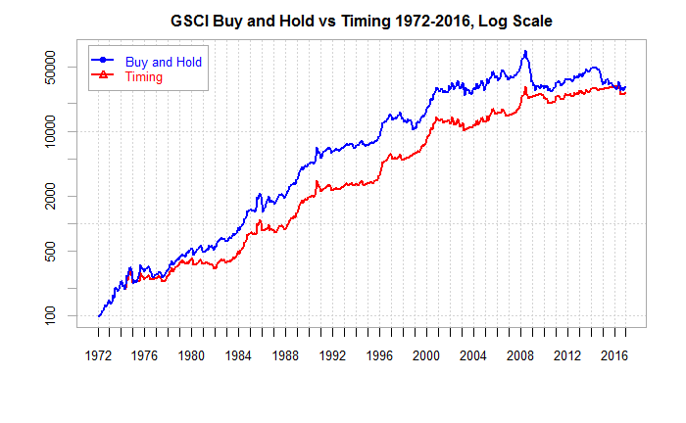

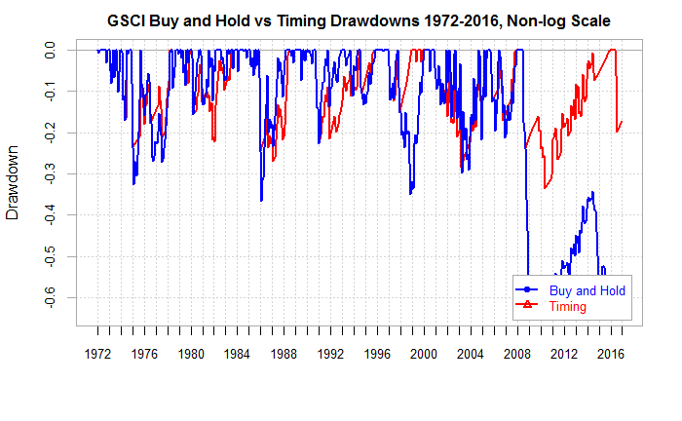

|  |  |  |
| --- | --- | --- |
|  | Buy and Hold | Timing |
| Return | 13.60% | 13.17% |
| Volatility | 22.88% | 19.00% |
| Sharpe | 0.44 | 0.50 |
| MaxDD | -64.08% | -33.50% |
| % Positive Months |  |  |

[Need to add $100 becomes… Sharpe RF, differences column]

Commentary:

* Most measures better.
* Interesting that the ZAR improves returns compared to USD GSCI

### JSAPY

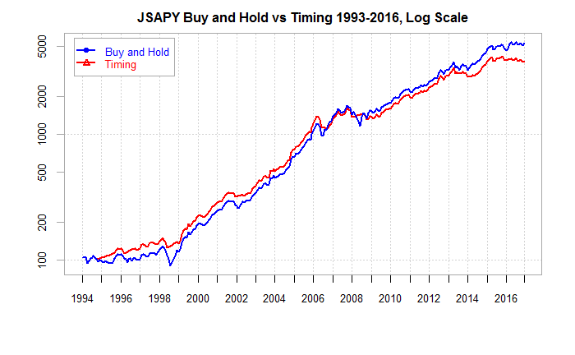

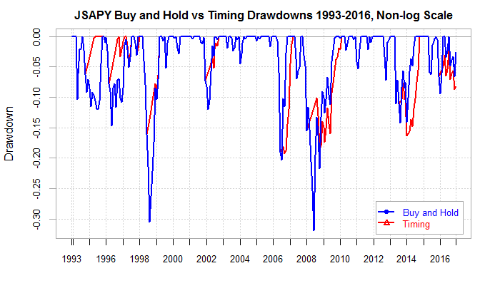

|  |  |  |
| --- | --- | --- |
|  | Buy and Hold | Timing |
| Return | 19.40% | 17.71% |
| Volatility | 15.85% | 13.26% |
| Sharpe | 1.15 | 1.26 |
| MaxDD | -31.87% | -19.25% |
| % Positive Months |  |  |

[Need to add $100 becomes… Sharpe RF, differences column]

Commentary:

* Again slightly less CAGR but less volatility and higher sharp / lower drawdown.

## Systematic Tactical Asset Allocation South Africa

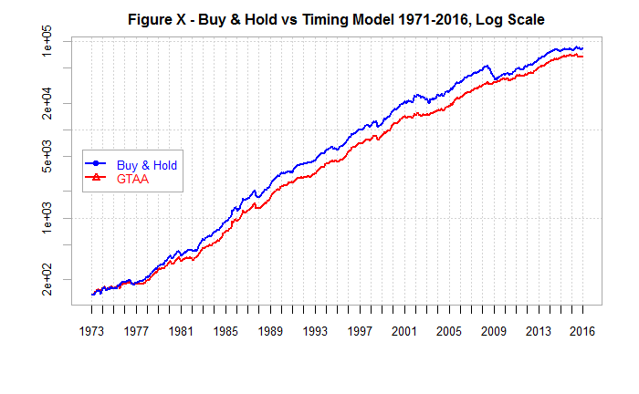

|  |  |  |
| --- | --- | --- |
| **Summary Annualised Returns for B&H vs Timing Model, 1973-2012** | | |
|  | Buy & Hold | GTAA |
| Return | 15.73% | 15.13% |
| Volatility | 10.98% | 8.80% |
| Sharpe | 0.42 | 0.46 |
| MaxDD | -30.61% | -11.59% |
| Inflation CAGR | 9.56% | 9.56% |

The absolute returns of the timing strategy are slightly worse however a larger drop in volatility results in a higher sharpe ratio. Importantly for investors, the biggest drawdown is 11.59%, approximately a third of the buy and hold.

Look at rolling returns / annual returns vs benchmark

## Performance returns 1993-2016 including property

Now lets add property and compare since 1992

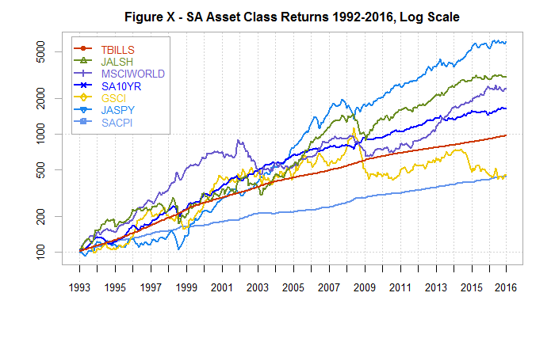

|  |  |  |  |  |  |  |
| --- | --- | --- | --- | --- | --- | --- |
| **Figure X - South African Asset Class Maximum Drawdowns 1992-2016** | | | | | | |
|  | TBILLS | JALSH | MSCIWORLD | SA10YR | GSCI | JASPY |
| Return | 9.93% | 15.29% | 14.18% | 12.41% | 6.51% | 18.64% |
| Volatility | 1.00% | 18.24% | 16.17% | 8.00% | 22.66% | 15.67% |
| Sharpe (9.93%) | 0.00 | 0.27 | 0.24 | 0.28 | -0.14 | 0.51 |
| MaxDD | 0.00% | -40.44% | -49.90% | -18.63% | -64.08% | -31.87% |
| Inflation CAGR | 6.33% | 6.33% | 6.33% | 6.33% | 6.33% | 6.33% |

Adding property will make a big difference – it’s the best performing asset since 1992. Also interesting to note over this period commodity returns are just slightly better than inflation which has lowered to 6.33%.

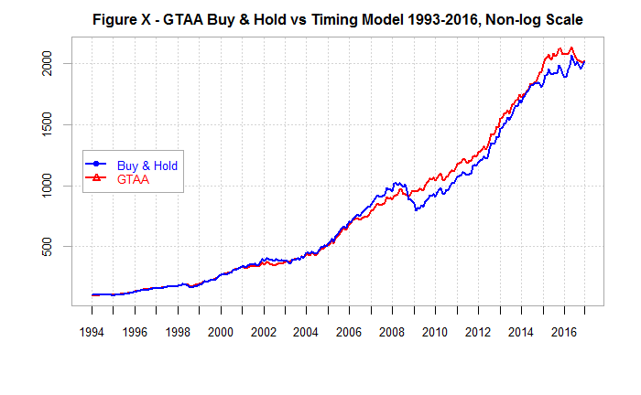

|  |  |  |
| --- | --- | --- |
| **Summary Annualised Returns for B&H vs Timing Model, 1994-2016** | | |
|  | Buy & Hold | GTAA |
| Return | 14.28% | 14.30% |
| Volatility | 9.44% | 7.04% |
| Sharpe | 0.43 | 0.58 |
| MaxDD | -22.19% | -9.59% |
| Inflation CAGR | 6.19% | 6.19% |

Including property, the timing strategy is slightly better/equal to the buy and hold. Again the timing strategy’s volatility is lower and max drawdown is still in the single figures.

# Ideas and tests to improve Fabers results

Although performance metrics exhibit solid performance over a basket of US assets, when applied to South Africa its clear the outperformance isn’t as strong. Why? Is it a case of overfitting in Faber’s paper, or a unique case where trend following rules don’t apply to a south Africa asset allocation?

A trend following signal such as the simple moving average signal, is designed to capture the middle of trends.

In consolidating markets, the strategy’s performance typically suffers from range bound markets and whipsaws. Whipsaws are when a long signal is created and suddenly reverses to hit a stop.

To avoid whipsaws, there are a couple of methods used:

* Delayed entry
* Bands

Ultimately these entries delay entry into the trade, at the expense of missing out of the first part of the move. However they help avoid costly whipsaws.

Lastly as Faber has pointed out, diversification can also somewhat improve returns, again at a cost of increased taxes/trading fees.

numbers

* Diversifying with more asset classes:
  + We have only looked at asset classes in these example. Clare et all (2012 pg 8) research shows splitting an asset class into its components parts add value. Although perhaps too time consuming for retail investors, institutional investors could target better risk adjusted returns applying these strategies on individual assets within these broad asset classes.
  + Also add different asset classes – comment on how more and more is becoming available. Perhaps bitcoin as an example of an uncorrelated asset that could improve results.Diversifying using more moving average periods
* Using EMA
* Using vol filter
* Long and short (pg 158 faber ivy)
* Overlaying a mean reverting
* Pyramid in / out approach
* Signal has to be 1% above or below to change
* No bonds – already exposed to fixed income through treasuries – can remove and increase returns. However this will remove downside?
* High vol asset classes give better returns on a timing strategy (faber ivy 2009)

## Improving returns

On analysis it appears the performance of the Systematic Tactical Asset Allocation with South Africa assets suffers due to domestic equities in the late 1970s. [Questionable data? – look to confirm]

Look at:

* adding more assets (can’t no data?) and   
  diversifying the moving average to longer and shorter signals
* look at exponential moving average

On further analysis it appears the performance of the Tactical market timing strategy with South African assets

The problem with trend following strategies is that they have a lot of false positives.

Entry signals from breakouts or moving averages give false signals

Market whipsaws

30% win rate

Trend following rules aren’t meant to pick the bottom or time the exit to the top – they aim to identify a trend, hope on board and ride it for as long as it goes.

In consolidating or range bound markets, trend following systems get whipsawed

Benefits of diversification also apply to strategies – rather than picking one moving average , better to pick multiple and diversify the outcome. Downside is costs/taxes however with these assets trading costs are assumed to be minimal and worth the better returns. Taxes also are fine – fabers comments about winners being longer, etc.

Performance review – looks like similar returns, however signal doesn’t avoid biggest drawdowns. Actually worse for equities, its in the market for the initial crash, market rebounds and sends false signal to enter.

Improvement ideas:

* **diversification** of signals : 2, 5, 10 and 20m simple moving avgs, look at moving average crosses (why?),
* **delaying entry** to avoid whipsaws : When the signal is given we don’t enter straight away, we wait a month to make sure signal still exists before entering
* **trading bands** to make market show conviction.

## Comparison to local SA funds

[change this to average timing] Retail funds in South Africa are known as Collective Investment Schemes (CISs) and are regulated under the Collective Investment Schemes Control Act 2002 (CISCA). Funds are then categorised according to classifications specified by the Association for Savings and Investment South Africa (ASISA), an industry body which assists the Financial Services Board with the regulation of the industry. ASISA uses a three tier classification system focusing on geographically where the fund will be invested (tier 1), what assets the fund invests in (tier 2) and then what the main focus of the fund will be (tier 3). One of the objectives of ASISA’s classification system is to facilitate the comparison of funds both across and within categories.

To compare the performance of the market timing strategy against comparative funds, the asset allocation has to be adjusted to fit within specific classification constraints. Two potential fund classifications that would only require minor reweighting to the equal weighted original allocation are Worldwide Multi Asset Flexible portfolios and South Africa Multi Asset High Equity portfolios.

To fit within the Worldwide Mule Asset Flexible classification, the asset allocation has relative little constraints from ASISA. No minimum is set for domestic or foreign assets and they have complete flexibility in their asset allocation between and within asset class. Only CISCA regulations apply which in this case restricts commodity exposure to 10% [need to confirm this is the only constraint applicable here]. As such the following asset allocation has been selected:

* 22.5% Domestic Equity
* 22.5% Foreign Equity
* 22.5% Fixed Income
* 22.5% Property
* 10.0% Commodities

To fit within the South Africa Multi Asset Flexible classification, the fund must effectively invest at least 75% of their assets in South African investment markets considering a maximum of 25% of their assets can be assets outside of south Africa. [is there a commodity index or offshore equity index listed locally that counts as local?]. Combined with CISCA regulations, the following asset allocation has been selected:

* 25.0% Domestic Equity
* 15.0% Foreign Equity
* 25.0% Fixed Income
* 25.0% Property
* 10.0% Commodities

Ultimately the differences between each classification are minimal are seen in the following chart.

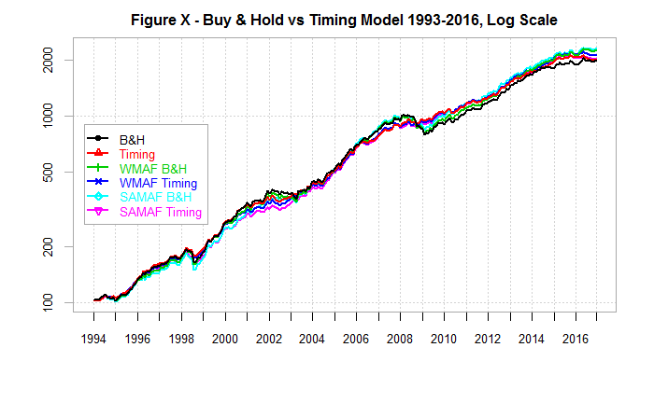

When comparing performance statistics, we see:

|  |  |  |  |  |  |  |
| --- | --- | --- | --- | --- | --- | --- |
| **Figure X - South African Fund Classification Performance 1993-2016** | | | | | | |
|  | B&H | Timing | WMAF B&H | WMAF Timing | SAMAF B&H | SAMAF Timing |
| Return | 14.28% | 14.30% | 14.95% | 14.63% | 15.06% | 14.42% |
| Volatility | 9.44% | 7.04% | 9.22% | 7.00% | 9.22% | 7.13% |
| Sharpe (9.84%) | 0.43 | 0.58 | 0.51 | 0.63 | 0.52 | 0.59 |
| MaxDD | -22.19% | -9.59% | -18.75% | -11.52% | -19.22% | -13.62% |
| Inflation CAGR | 6.19% | 6.19% | 6.19% | 6.19% | 6.19% | 6.19% |

How do these compare to similar classification funds in South Africa? [waiting for more info from peregrine/pres/seed]

Morningstar is an investment research firm that provides performance reporting of ASISA funds in South Africa. Each month they release performance figures comparing funds of the same ASISA classification. Comparing each strategy to the peers we see mixed results with some periods of outperformance and some periods of underperformance.

|  |  |  |  |  |  |  |  |
| --- | --- | --- | --- | --- | --- | --- | --- |
|  | 3m | 6m | 1yr | 3yr | 5yr | 7yr | 10yr |
| Peer Group Average | -1.41% | -1.56% | -3.75% | 7.31% | 13.95% | 12.02% | 9.74% |
| WMAF B&H | 3.93% | 0.82% | 5.80% | 8.29% | 13.42% | 13.07% | 10.59% |
| WMAF Timing | -0.41% | -4.36% | -1.25% | 5.92% | 11.42% | 10.66% | 10.63% |

|  |  |  |  |  |  |  |  |
| --- | --- | --- | --- | --- | --- | --- | --- |
|  | 3m | 6m | 1yr | 3yr | 5yr | 7yr | 10yr |
| Peer Group Average | -1.27% | -0.40% | 1.72% | 5.50% | 10.82% | 10.28% | 8.87% |
| SAMAF B&H | 3.26% | 0.92% | 6.83% | 7.94% | 12.62% | 12.62% | 10.57% |
| SAMAF Timing | -1.27% | -3.62% | -0.33% | 5.39% | 10.49% | 10.20% | 10.30% |

# Conclusion

Write when finished

# Appendix 1 – Data validity check

|  |  |  |  |  |  |  |
| --- | --- | --- | --- | --- | --- | --- |
| **Figure 4 - Asset Class Maximum Drawdowns 1973-2012** | | | | | | |
|  | TBILLS | SP500 | EAFE | US10YR | GSCI | NAREIT |
| Return | 5.42% | 9.77% | 9.19% | 8.12% | 8.34% | 9.64% |
| Volatility | 0.95% | 15.71% | 17.60% | 8.47% | 20.55% | 18.16% |
| Sharpe (??%) | 0.00 | 0.26 | 0.20 | 0.30 | 0.13 | 0.22 |
| MaxDD | 0.00% | -50.95% | -56.40% | -15.75% | -67.65% | -68.18% |
| Inflation CAGR | 4.33% | 4.33% | 4.33% | 4.33% | 4.33% | 4.33% |

Comparing to Fabers original numbers we see these small differences: (should this be in appendix with a comment saying comfortable obtained data represents the same asset classes?)

|  |  |  |  |  |  |  |
| --- | --- | --- | --- | --- | --- | --- |
| **Figure 5 - Differences to Faber's Original Research 1973-2012** | | | | | | |
|  | TBILLS | SP500 | EAFE | US10YR | GSCI | NAREIT |
| Return | 0.01% | 0.07% | 0.02% | -0.06% | 0.02% | -0.01% |
| Volatility | 0.00% | 0.02% | -0.01% | 0.03% | 0.00% | 0.03% |
| Sharpe | 0.00 | -0.01 | -0.01 | -0.03 | -0.01 | -0.01 |
|  | 0.00% | 0.00% | 0.00% | 0.04% | 0.00% | -0.30% |
| Inflation CAGR | 0.03% | 0.03% | 0.03% | 0.03% | 0.03% | 0.03% |

Differences here to the original paper are small:

* Differences in returns <0.07%
* Differences in volatility <0.03%

Suspect this is from small differences between data providers. Comfortable using for rest of research.

# Appendix 2 – Using R code

Write about experience learning R

I have chosen to learn and use R to replicate Faber's Research for use as the core strategy. R is a language...

R has the advantages of:

* R is free
* R is open source there are thousands of packages that will assist replicating the research and testing further ideas. These packages speed up processes and provide functions such as performance metrics that you would have to code from scratch.
* R has a large active user base with muiltiple ways to access support

R also has some disadvantages:

* R has a steep learning curve, multiple hours spent learning the basics and debugging
* The access to support can be slow – logging issues on forums to try get help.
* R can be clunky – language written in 1970…
* Hard to customise some graphs/tables and edit tables without a GUI like Excel
* Several times during this research, a package used to provide functions underwent updates, causing code to fail and results to no longer work.

Packages used:

* Performance analystics: Collection of econometric functions for performance and risk analysis
* Quantmod – helping upload/download download from online resources such as Fred / Yahoo Finance
* Quanstrat – Specify, build, trade, and analyse quantitative financial trading strategies.
* Dplyr

# References

Domanski, Dietrich and Heath, Alexandra (2007). Financial Investors and Commodity Markets. BIS Quarterly Review, March 2017, p. 53-67.

Faber, Meb (2006). A Quantitative Approach to Tactical Asset Allocation (working paper).

Faber, Meb (2007). A Quantitative Approach to Tactical Asset Allocation. The Journal of Wealth Management, Spring 2007, p 69-79

Clenow, Andreas (2013). Following the Trend.

Ibbotson et all. 2016 Stocks, Bonds, Bills and Inflation (SBBI) Yearbook year book

Jennings, William W. and Payne, Brian C (2016). Fees Eat Diversifications Lunch. Financial Analysts Journal, Volume 72, Issue 2, p. 31-40.

Markowitz, Harry (1952). Portfolio Selection. The Journal of Finance, Vol. 7, No. 1, p. 77-91)

[fill in once finished]

(Domanski and Heath, 2007)

(Faber, 2006)

Faber, Meb (2007). A Quantitative Approach to Tactical Asset Allocation. The Journal of Wealth Management, Spring 2007, p 69-79

Inker, B., (2020). “The Hidden Risks of Risk Parity Portfolios”, GMO White Paper

Faber, Meb, A Quantitative Approach to Tactical Asset Allocation (February 1, 2013). The Journal of Wealth Management, Spring 2007 . Available at SSRN: <https://ssrn.com/abstract=962461>

Faber, M., (2007). “A Quantitative Approach to Tactical Asset Allocation”, Journal of Investing, 16, 69-79.

Ilmanen A., (2011). Expected Returns.John Wiley & Sons

Friesen, G., Weller, P. and L. Dunham, (2009), “Price trends and patterns in technical analysis: A theoretical and empirical examination”, Journal of Banking & Finance, 33, 1089- 1100.

Clare, Andrew and Seaton, James and Smith, Peter N. and Thomas, Steve, The Trend is Our Friend: Risk Parity, Momentum and Trend Following in Global Asset Allocation (July 31st, 2015). Available at SSRN: https://ssrn.com/abstract=2126478 or http://dx.doi.org/10.2139/ssrn.2126478